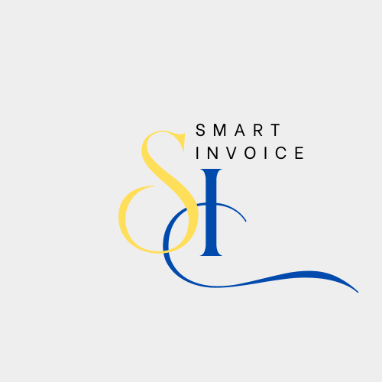

BY:Hasanhabbosh

The smart invoice is an ap

plication used to manage invoices in an updated and intelligent way, allowing business owners to create invoices, view them, send them to customers, and track them easily and efficiently. The goal of the smart invoice is to simplify the process of creating invoices, accurately calculating paid and due amounts.

**Main Functions of the Smart Invoice:**

1. **Issuing Invoices:**
   * The ability to automatically create invoices based on customer data and transactions.
   * Specify invoice details such as quantity, price, taxes, and discounts.
2. **Customer Management:**
   * Ability to add, edit, and delete customer information.
   * Link each invoice to customer data, making tracking easier.
3. **Sending Invoices:**
   * Automatically send invoices to customers via email or other applications.
4. **Invoice Tracking:**
   * Track the status of the invoice (paid, unpaid, postponed).
   * Display reports on paid and unpaid invoices.
5. **Customization:**
   * Customize the invoice design to match the company's identity.
   * Add the logo, headers, and other company-specific details.
6. **Exporting Invoices:**
   * The ability to export invoices to PDF or Excel files for easy sharing or storage.
7. **Reporting:**
   * The ability to generate detailed reports on sales, customers, and payments to track financial performance.
8. **Integration with Other Systems:**
   * Ability to integrate with accounting and inventory systems for automatic data updates.

**Requirements:**

**The website is built using HTML, JavaScript, CSS, .net and C#.**

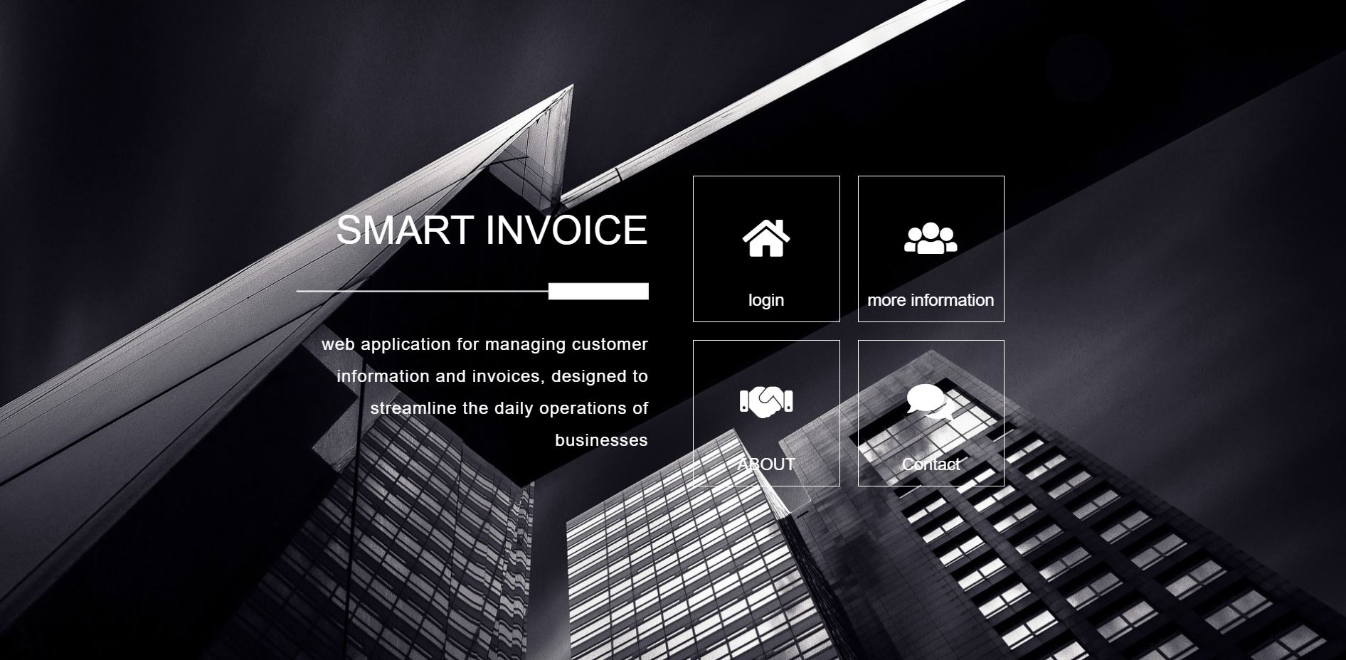

**Homepage Overview**

The homepage is the main interface that users see when they visit the website. It will consist of several key sections to provide visitors with a clear and organized experience. Here's an overview of the sections that will be included on the homepage:

1. **Login Section**:
   * This section will include a login form where users can enter their credentials, such as email and password, to access their accounts.
   * It may also include links for creating a new account or recovering a forgotten password.
2. **Additional Information Section**:
   * This section will contain text, images, or videos that explain more about the website or the service you provide.
   * The goal of this section is to offer more details to new visitors on how they can benefit from the website or learn about the different services available.
3. **Contact Section**:
   * This section will allow users to find contact information for reaching out to you or your support team.
   * It may include a simple contact form where visitors can enter their name, email, phone number, and their inquiry.
   * You may also include direct contact details, such as an email address or phone number.

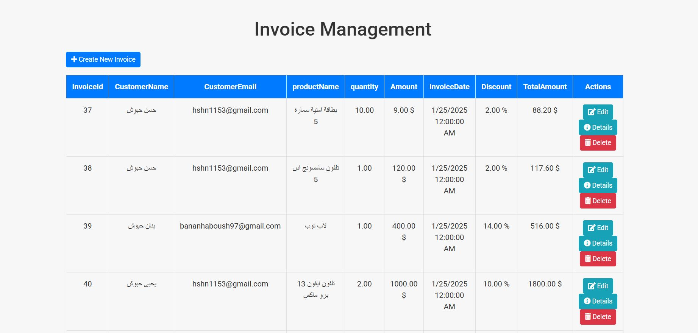

In this system, invoices are fully managed, allowing users to create invoices automatically based on the entered information and data, such as customer details and the products or services provided. Once the invoice is created, it is easily sent to the customer through electronic means like email.

This helps streamline the workflow by speeding up the invoicing process and ensuring its accuracy, saving both time and effort. The system also allows users to track the status of the invoice, whether it's paid or unpaid, and send reminders to the customer in case of delayed payments.

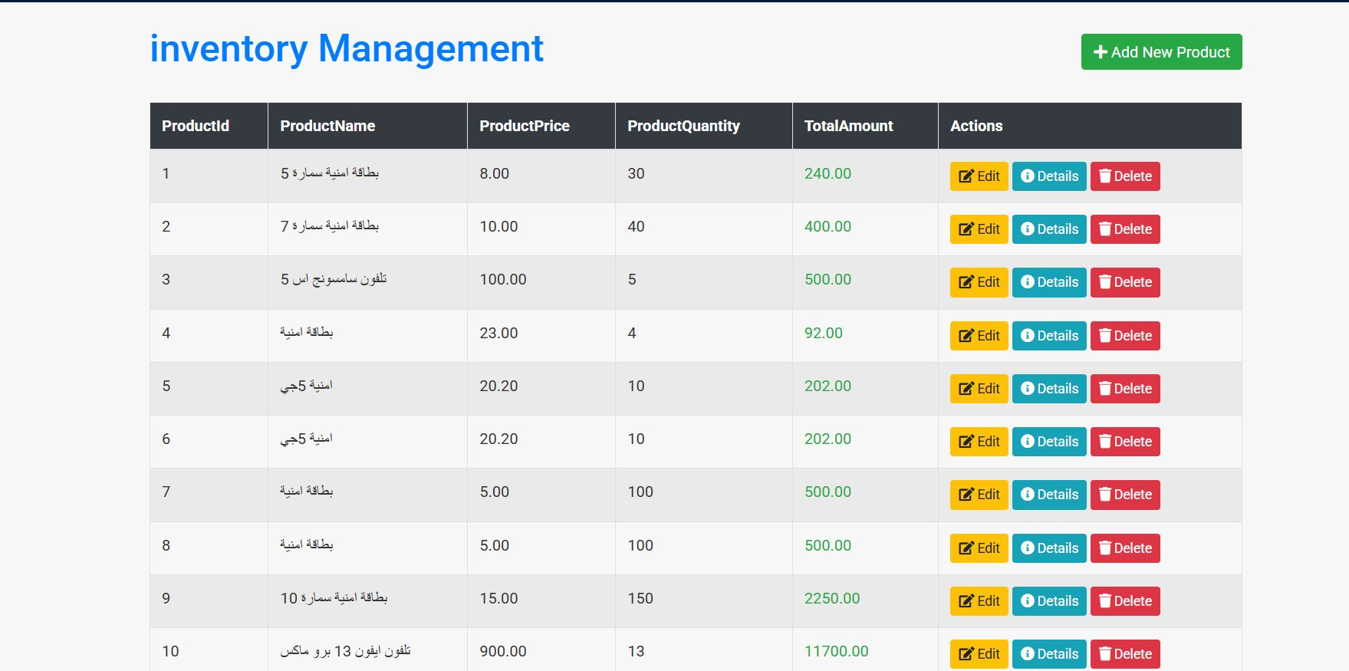

The Inventory Page is a crucial part of the system that helps in managing and updating the quantities of products or materials available in stock continuously. The purpose of this page is to track the available stock of each product and provide accurate real-time information, which helps improve inventory management and ensures product availability at all times.

**Main Functions of the Inventory Page:**

1. **Displaying Products:**
   * Display a comprehensive list of all products available in stock, with details such as name, code, available quantity, and price.
2. **Updating Quantities:**
   * Ability to add or modify the quantities available for products during shipping or receiving, ensuring the data is continuously updated.
3. **Order Management:**
   * Ability to link products to orders placed by customers, making it easier to track stock consumption.
4. **Low Stock Alerts:**
   * A notification system that sends alerts when the stock of a product drops below a certain threshold, helping to avoid stockouts.
5. **Search and Filter:**
   * The ability to search for products by name, code, or category, with options to filter results based on various criteria.
6. **Data Export:**
   * Ability to export the inventory list to Excel or PDF files for review or sharing with relevant parties.
7. **Inventory Reports:**
   * Generate reports showing inventory movement, whether an increase or decrease in quantities, to help management make data-driven decisions.

**Benefits:**

The Inventory Page helps improve the overall efficiency of the company by providing a clear and accurate view of inventory status. This makes it easier to make purchasing and storage decisions, reducing the chances of stock shortages or overstocking.

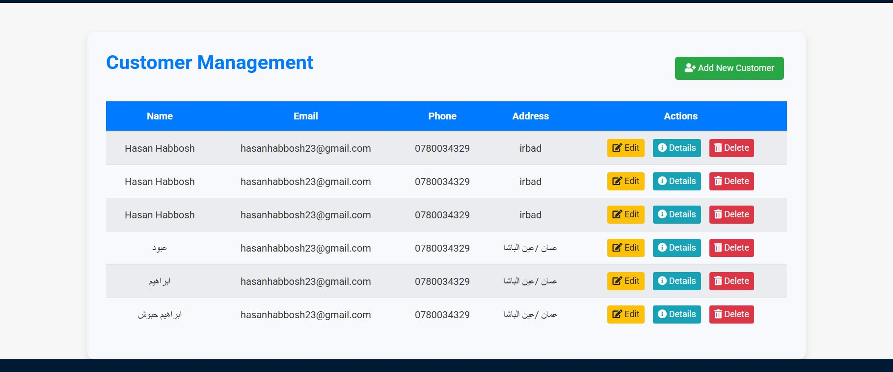

The **Customer Management Page** is the part of the system that allows administrators or staff to manage customer information in an integrated way. On this page, users can add new customers, edit their details, view their information, and track their transaction history.

**Main Functions of the Customer Management Page:**

1. **Add and Edit Customers:**
   * The ability to add new customers to the system with details such as name, address, phone number, and email.
   * Edit customer information in case any details change, such as a new address or phone number.
2. **View Customer Details:**
   * Ability to view each customer's details, including contact information, previous transactions, associated invoices, and outstanding balances if any.
3. **Account Management:**
   * The ability to assign accounts to each customer based on their type or category, linking them to financial accounts or payment invoices.
4. **Search and Filter:**
   * The ability to search for customers based on specific criteria, such as name, phone number, email, or customer category.
   * Filter customers based on financial transactions or account status.
5. **View Transaction History:**
   * Ability to track the transaction history for each customer, including payments, invoices, and any discounts applied.
6. **Manage Account Status:**
   * The ability to change the account status, such as activating, deactivating, or deleting a customer’s account if they are no longer active or are not engaging with the system anymore.
7. **Generate Reports:**
   * The ability to generate detailed reports about customers, such as reports showing customers with outstanding balances or the most active customers.

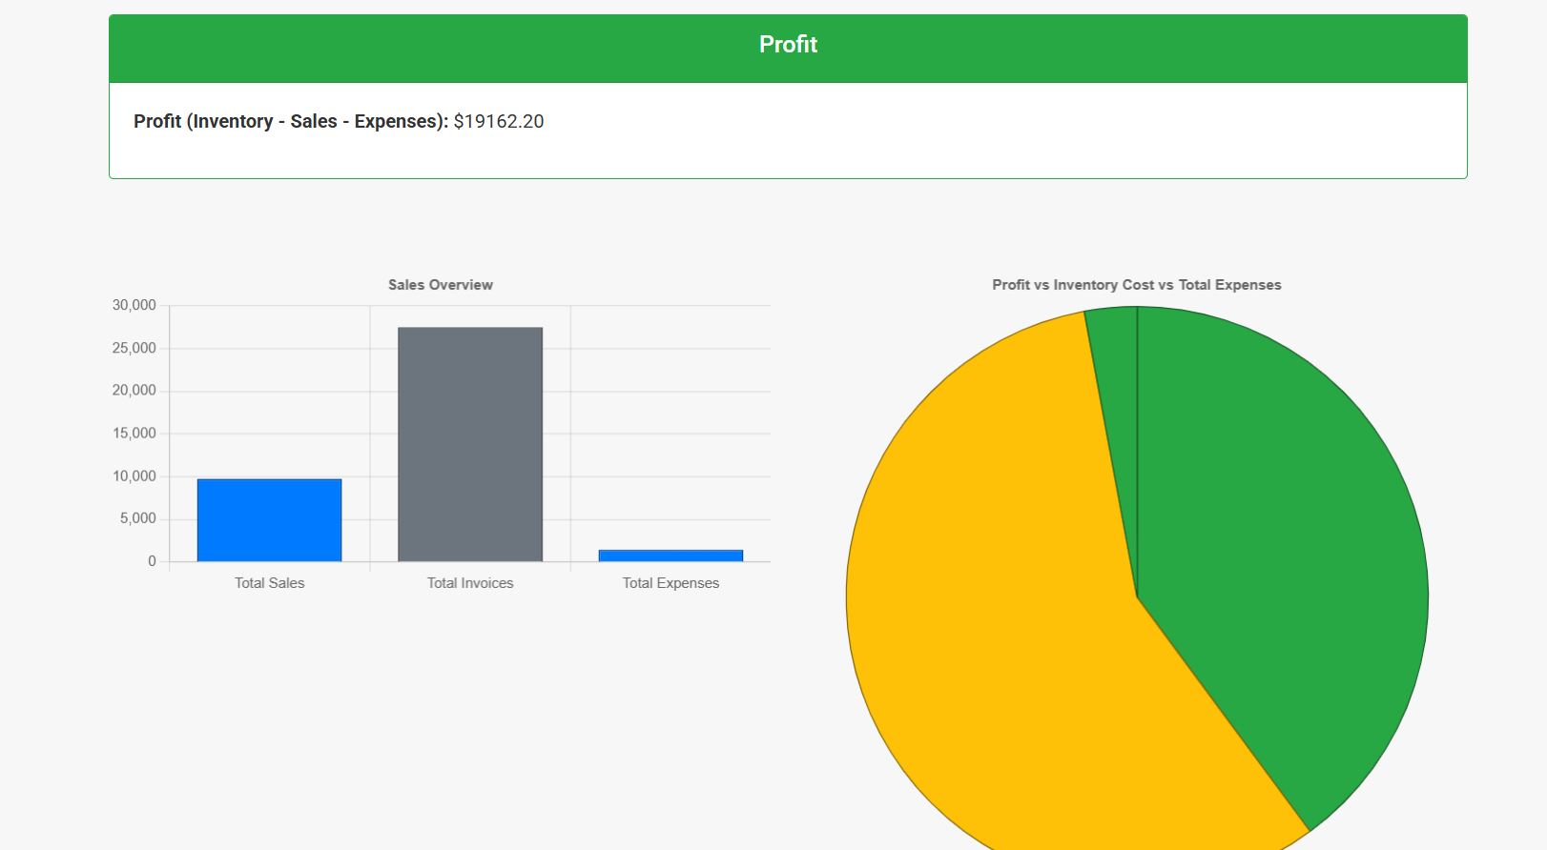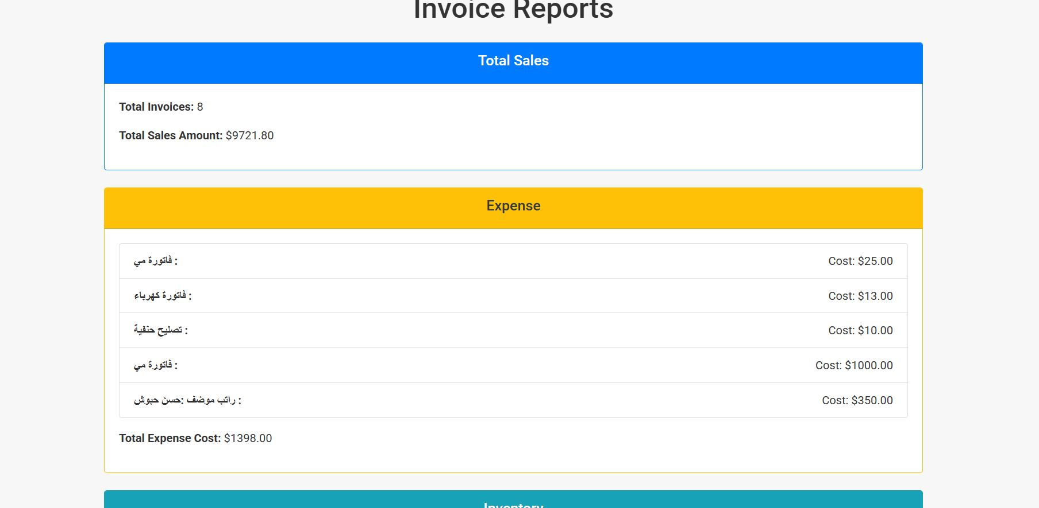

**Main Functions of the Financial Reports Page:**

1. **Revenue and Expense Reporting:**
   * Display detailed reports on the revenue generated and expenses paid during a specific period.
   * Analyze financial data to understand the sources of revenue and expenditures.
2. **Profit and Loss Calculation:**
   * Provide reports showing net profits and losses over specific periods (monthly, quarterly, annually).
   * Analyze changes in profits and losses and compare performance with previous periods.
3. **Accounts Receivable Reports:**
   * Display reports on outstanding customer accounts, including due payments or unpaid invoices.
   * Track customer debt and outstanding balances.
4. **Cash Flow Analysis:**
   * Present analytical reports on incoming and outgoing cash flow, helping to monitor financial liquidity.
   * Understand how income and expenses impact liquidity.
5. **Financial Performance Comparison:**
   * Compare financial performance against previous periods or predefined financial goals.
   * Display comparative reports between revenues and expenses across different timeframes.